Software Requirements
Specification
for

<No Waste>

Version 1.0

Prepared by <Maryam Noureldin, Mennatallah Zaid, Marina Mikhael, Eman Abd Elhady, Farah Habib >

<10/14/2026>

Copyright © 1999 by Karl E. Wiegers. Permission is granted to use, modify, and distribute this document.

Table of Contents
Table of Contents ii
Revision History ii
1. Introduction 1
1.1 Purpose 1
1.2 Document Conventions 1
1.3 Intended Audience and Reading Suggestions 1
1.4 Product Scope 1
1.5 References 1
2. Overall Description 2
2.1 Product Perspective 2
2.2 Product Functions 2
2.3 User Classes and Characteristics 2
2.4 Operating Environment 2
2.5 Design and Implementation Constraints 2
2.6 User Documentation 2
2.7 Assumptions and Dependencies 3
3. External Interface Requirements 3
3.1 User Interfaces 3
3.2 Hardware Interfaces 3
3.3 Software Interfaces 3
3.4 Communications Interfaces 3
4. System Features 4
4.1 System Feature 1 4
4.2 System Feature 2 (and so on) 4
5. Other Nonfunctional Requirements 4
5.1 Performance Requirements 4
5.2 Safety Requirements 5
5.3 Security Requirements 5
5.4 Software Quality Attributes 5
5.5 Business Rules 5
6. Other Requirements 5
Appendix A: Glossary 5
Appendix B: Analysis Models 5 (for upcoming milestone)
Appendix C: To Be Determined List 6

Revision History

Name | Date | Reason For Changes | Version
Maryam | 2026-11-05 | Updated from the Sprint 1 code, phone testing and the TA and professor feedback: listings with branches and shelf-life rules (no preparation time or expiry), the category set on saving and shown only to vendors, Quick Post start and category, the map with a distance slider, availability and reliability wording, mobile data wording, and new administrator stories US-46 to US-50 for Sprint 3, including approval of every listing before it is published. Decisions D-11 to D-77 in PROGRESS.md. | 1.1
Menna | 2026-11-09 | Sprint 2, US-12: AI vision provider chosen for development (Groq, D-85); AI draft details (D-80 to D-84) | 1.2

1. Introduction

1.1 Purpose
This Software Requirements Specification (SRS) defines the requirements of NoWaste, version 1.0, a location-based mobile app that reduces food waste in Egypt. It covers the whole product described in Section 4, not only the subset the team builds by 1 December. The features the team commits to build are listed separately in the implementation scope of the Milestone 1 report. The document is updated every sprint.

1.2 Document Conventions
● Shall marks a mandatory statement. Every requirement has one identifier.
● Identifiers: FR-xxx-nn is a functional requirement, where xxx is the feature (ACC accounts, LST listings, RTE perishability and routing, RES search and reservation, AST AI assistant, TGI trust, giving and impact). E-xxx-nn is an error condition of that feature. US-nn is the user story a requirement traces to. NFR-nn is a nonfunctional requirement and BR-nn a business rule (Section 5).
● Priority: every requirement carries its own priority and does not inherit the priority of its feature. High means the product does not work as described without it. Medium means the core flow works without it, but it is important. Low means desirable. Priority records importance to the product; it does not record whether the team will build it by 1 December.
● TBD marks a value that is not yet decided. Every TBD is listed in Appendix C until it is closed.
● Timings and limits (hold length, waitlist time, refund window, no-show limit) are stated in Section 4 and listed together as business rules in Section 5.5.

1.3 Intended Audience and Reading Suggestions
● Course instructor and teaching assistants: read Sections 1 and 2, then Section 4 and Appendix C, to check scope, completeness and traceability.
● Developers: read Sections 2 and 3, then Section 4 for the feature being built, to see what to build and its error cases.
● Testers: read Section 4 (requirements and error conditions) and Section 5 (limits and verification), to see what to verify and how.
● Project manager (team): read Sections 2 and 4 and Appendix C, to track priorities and open items.
The rest of this document is organised as follows:
● Section 2 describes the product, its users and its environment.
● Section 3 defines the interfaces to users, hardware, other software and the network.
● Section 4 specifies the six features: accounts and administration, listings, perishability and routing, search and reservation, the AI assistant, and trust, giving and impact.
● Section 5 gives the nonfunctional requirements and business rules.
● Section 6 holds other requirements.
● The appendices hold the glossary, the analysis models (use case diagrams) and the list of open TBDs.

1.4 Product Scope
NoWaste lets vendors in Egypt post surplus food and sends it to the best destination: consumers at a discount first, then charity, then composting, with landfill only as a last resort. A vendor photographs the food, AI drafts the listing and an estimated calorie range, and the vendor confirms or edits every result. Consumers browse nearby offers, reserve with or without a payment card, and collect the food with a 6-digit pickup code. Charity and composting partners accept donations and compost offers, and an administrator approves every vendor and partner. The app is available in Arabic and English.
The objectives are to:
● let vendors recover money from food that would otherwise be thrown away;
● give students and budget-conscious households cheaper food, including people without a payment card;
● send food to people and charity before compost, and compost before landfill;
● support the UN target to halve food waste (SDG 12.3).
Out of scope: delivery of food, and any statement that food is safe to eat. The app never certifies food as safe; perishability categories are estimates of pickup urgency that the vendor confirms.

1.5 References
Institute of Electrical and Electronics Engineers. (2009). IEEE standard for information technology—Systems design—Software design descriptions (IEEE Std 1016-2009).
ISO/IEC/IEEE. (2018). Systems and software engineering—Life cycle processes—Requirements engineering (ISO/IEC/IEEE Standard No. 29148:2018).
United Nations. (2015). Transforming our world: The 2030 Agenda for Sustainable Development (A/RES/70/1). https://sdgs.un.org/2030agenda
Wiegers, K. E. (1999). Software requirements specification.

2. Overall Description

2.1 Product Perspective
NoWaste is a new, self-contained product. It does not replace an existing system and is not part of a product family. Apps such as Too Good To Go solve the same problem abroad, but they assume card payment, registered vendors and reliable mobile data; NoWaste is designed for a market where none of these can be assumed.
The product has four parts:
● Mobile app: one app for all roles. What a user sees depends on their role: consumer, vendor, charity partner, composting partner or administrator.
● Backend: a REST API that holds the business rules (Section 5.5) and serves the app.
● Database: PostgreSQL with the PostGIS extension, which stores accounts, listings, reservations and locations.
● External services: a payment gateway, an AI service, a map service and a push notification service and an email and SMS service. The product calls these services and does not provide them. Section 3.3 describes each interface.
The component diagram in the SDD (Section 3) shows how these parts are divided and connected.

2.2 Product Functions
NoWaste has 60 functional requirements in six features. Section 4 specifies each one.

Feature | Main functions | Requirements
4.1 Accounts and administration | Consumer registration and login; vendor and partner applications approved by the administrator; password reset; profile; switching between Arabic and English; vendor branches with opening hours; administrator management of perishability rules and business-rule settings | FR-ACC-01 to 11
4.2 Listings | Create a listing from a photo with an AI-drafted description; Quick Post for informal vendors; food category and storage, with pickup at one of the vendor's branches; administrator approval of every listing before it is published; edit, cancel and view listings; suggested discount; estimated calorie range | FR-LST-01 to 09
4.3 Perishability and routing | Perishability category and pick-by time from shelf-life rules; recommended destination (consumers, charity, composting, landfill); most urgent food shown first; donation and compost pickups; automatic charity offers; landfill record | FR-RTE-01 to 13
4.4 Search, reservation and payment | Map search with filters; reservation by card or without a card; waitlist; pickup code; push notifications; cancellation, refund and no-show limits | FR-RES-01 to 13
4.5 AI assistant | Find food by typing or speaking; answers read aloud; reservation after the user confirms; vendor help | FR-AST-01 to 04
4.6 Trust, giving and impact | Ratings and reviews; no-show flags; donating a bag to charity as Zakat with a receipt; impact numbers; Ramadan mode; reporting a bad bag, reviewed by the administrator | FR-TGI-01 to 10

2.3 User Classes and Characteristics
The user classes come from the stakeholders of the product. All classes share login, profile and language switching. Consumers and vendors are the most important classes, because without both there are no sales to make. Society and the environment are stakeholders that benefit from the product, but they have no role in the app and are not a user class.

Class | Who they are | Main functions used | Characteristics and privileges | Importance
Consumer | Students and budget-conscious households | Search, reserve, pay, collect with a pickup code, rate, assistant, Zakat, impact numbers | Registers directly; may not have a payment card; may have a slow or limited data connection; uses Arabic or English | Most important
Formal vendor | Restaurants and grocery chains | Full listings, reservations, pickup code, destination choice | Needs administrator approval before posting; enters the food category and storage; picks up at one of its branches | Most important
Informal vendor | Street stalls and small bakeries that are not formally registered | Quick Post, reservations, pickup code | Needs administrator approval; wants to post fast without a full dashboard, so Quick Post asks only for a photo, a name and description, number of bags, price and pickup time | Most important
Charity partner | Charities such as the Egyptian Food Bank | Accept Donation listings, schedule pickups, collect with a code | Needs administrator approval; states the food types it accepts | Important
Composting partner | Organisations that compost food unfit for people | Accept Compost offers, schedule pickups | Needs administrator approval; states the food types it accepts | Important
Administrator | The person who keeps the network trustworthy | Approve or reject applications, approve or reject listings before they are published, suspend or remove accounts, review flagged accounts and bad-bag reports, manage perishability rules and business-rule settings | Highest privilege; few users and infrequent use | Important

2.4 Operating Environment
● Mobile app: runs on Android and iOS and is built with React Native from one shared codebase. The minimum supported versions of Android and iOS are TBD (Appendix C, TBD-1).
● Device features: the app needs a camera (listing photos), GPS location (search and routing) and an internet connection. It also uses the push notification service of the operating system.
● Network: mobile data, which may be slow or drop. NoWaste does not control the network; it keeps requests and photos small, uses timeouts with retry, and keeps an active reservation on the device. Core screens are verified on a simulated Fast 3G connection (NFR-08).
● Backend: a REST API server reached over HTTPS. The backend framework is TBD (Appendix C, TBD-2).
● Database: PostgreSQL with the PostGIS extension.
● External services: a payment gateway, an AI service, a map service and a push notification service an email and SMS service . The providers are TBD (Appendix C, TBD-2).
● Languages: Arabic (right-to-left) and English.

2.5 Design and Implementation Constraints
● Technology: React Native for the app, a REST API over HTTPS between the app and the backend, and PostgreSQL for data.
● Language: every screen shall support Arabic (right-to-left) and English (NFR-06).
● Payment data: card details are handled only by the payment gateway and are never stored by NoWaste (NFR-10). Payments during the course use the gateway’s sandbox mode only.
● Food safety: the product never certifies food as safe. AI results are drafts that the vendor confirms, and the pickup window cannot end after the pick-by time worked out from the shelf-life rules (NFR-05).
● AI dependence: the core functions shall work when the AI service is unavailable (NFR-03).
● Personal data: the product handles email addresses, phone numbers and locations. The team has not yet reviewed the legal obligations that apply to this data, to online payments, to charity collection or to food handling in Egypt. The product is a course project and is not a public launch.
● Development process: the team uses GitHub, GitHub Actions and Jira. Every merge runs automated tests and requires a code review (NFR-13).
● Schedule and team: five team members, with the first working version due on 1 December.
● Business rules: timings and limits are those in Section 5.5.

2.6 User Documentation
Each role gets in-app help in Arabic and English that explains its main tasks: posting a listing, reserving food, and confirming a pickup with a code. No printed manual or separate online help is planned.

2.7 Assumptions and Dependencies
Assumptions
● Consumers and vendors have a smartphone with a camera and GPS, and an internet connection that may be slow.
● Administrator accounts are created by the team directly. The product has no registration flow for administrators.
● All prices are in Egyptian pounds (EGP), and all times are in Egypt local time.
● The AI service recognises common Egyptian food well enough to produce a useful draft. The classification accuracy requirement (NFR-04) measures this, and the vendor corrects every draft.
● The payment gateway offers a sandbox mode that the team can use without a registered company.
● Charity and composting partners are represented by test accounts during the course.
Dependencies
● The product depends on five external services: the payment gateway, the AI service, the map service and the push notification service and an email and SMS service
● If one is unavailable, the core functions that do not need it continue to work (NFR-03, E-AST-02).
● The product depends on those services’ free or student usage limits being enough for development and demonstration.
● Section 2 depends on Section 4 for the feature and requirement counts, and Section 5 depends on Section 4 for the timings and limits.

3. External Interface Requirements
Each interface requirement has an identifier of the form IF-xxx-nn, where xxx is UI, HW, SW or COM, and cites the Section 4 requirements it supports. Where an external provider is not yet chosen, the service is named by its role (Appendix C, TBD-2).

3.1 User Interfaces
NoWaste has one app with a different set of screens for each role.

Role | Main screens
Any user | Language selection, registration, login, password reset, profile, impact numbers
Consumer | Nearby listings on a map with a distance slider and in a list with filters; listing details; reserve (card or no card); my reservations with the pickup code, check-in and cancel; waitlist; rating; report a bad bag; donate as Zakat; AI assistant; Ramadan mode
Vendor | New listing (photo, AI draft, details, allowed pickup window, destination); Quick Post; my listings; branches and opening hours; reservations for a listing; enter pickup code; suggested discount; flag a no-show; automatic charity offers; landfill record; application status
Charity partner and composting partner | Application status; Donation or Compost offers; accept an offer and propose a pickup time; enter pickup code
Administrator | Pending applications; approve, reject, suspend or remove an account; listings waiting for approval; flagged accounts; bad-bag reports; perishability rules; business-rule settings

● IF-UI-01 After login, the app shall open the home screen for the user’s role (FR-ACC-04).
● IF-UI-02 The app shall let any user switch between Arabic and English, including before registration and login (FR-ACC-09).
● IF-UI-03 In Arabic, the app shall mirror every screen right-to-left (NFR-06).
● IF-UI-04 The app shall label an estimated calorie range “Estimate” wherever it is shown (FR-LST-07).
● IF-UI-05 The app shall show the vendor a listing’s perishability category, with what it means in hours, as an indication of how soon the food should be collected, and shall show consumers the pickup window instead of the category. Neither shall be worded as a statement that the food is safe (FR-RTE-04, NFR-05).
● IF-UI-06 When an input is invalid, the app shall identify the invalid field (E-ACC-02, E-LST-04).
● IF-UI-07 The app shall show the pickup code of an active reservation on the consumer’s reservation screen (FR-RES-08).
● IF-UI-08 The sign-up, browse and reserve flows shall meet the accessibility requirements in NFR-07.

3.2 Hardware Interfaces
The app runs on smartphones with Android or iOS (versions TBD, Appendix C, TBD-1). It uses the following device hardware. The pickup code is typed in, so no code scanner is needed.
● IF-HW-01 The app shall let a vendor take a listing photo with the device camera (FR-LST-01, FR-LST-02).
● IF-HW-02 The app shall let a vendor choose an existing photo from the device gallery instead of taking one (FR-LST-01).
● IF-HW-03 The app shall read the device GPS location to register a vendor’s location and to find and rank listings near a consumer (FR-ACC-02, FR-RES-01, FR-RTE-08).
● IF-HW-04 If a user denies location permission, the app shall tell the user that nearby search needs the location. The user can then set the location by hand by placing a pin on the map or typing an address; the app uses it in the same way as a GPS location. Until a location is available, the map shows offers around central Cairo.
● IF-HW-05 The app shall use the microphone to take spoken requests and the speaker to read answers aloud when the user chooses the AI assistant (FR-AST-01, FR-AST-02).
● IF-HW-06 The app shall ask for each permission (camera, location, microphone, notifications) when the user first uses the feature that needs it, and shall explain why it is needed.
● IF-HW-07 If a permission is denied, the rest of the app shall continue to work.

3.3 Software Interfaces
The backend uses one database and five external services. Each row names the requirements the interface serves and the data that crosses it.

Interface | Used for | Sent by NoWaste | Received by NoWaste
Payment gateway | Card payment when reserving, refunds, and Zakat payments (FR-RES-02, FR-RES-12, FR-TGI-05, E-LST-05) | Amount in EGP, a reference to the reservation, and refund requests | Payment approved or declined, a payment reference, and refund status
AI service, listings | Classify the food photo, estimate calories, and draft the listing in Arabic and English (FR-LST-03, FR-LST-07, FR-RTE-02) | The compressed listing photo | Food type, food category, estimated quantity, estimated calorie range, draft text in Arabic and English, and a confidence value  Sprint 2: provided by Groq (qwen/qwen3.8-27b, Appendix C TBD-2). The calorie range is not asked for yet (US-16).
AI service, assistant | Understand typed or spoken requests and read answers aloud (FR-AST-01 to FR-AST-03) | The user’s text or audio | The text of the request, the matching search, the answer text, and audio for reading aloud
Map service | Show nearby listings on a map (FR-RES-01) | Map view requests with listing coordinates | Map tiles and the map view
Push notification service | Notify users about reservations, applications and listing changes (FR-RES-11, FR-ACC-07, E-LST-05)" | The device token and the message for each notification event | Delivery status
Email and SMS service | Send password-reset codes (FR-ACC-05, E-ACC-04) | The email address or phone number and the code | Delivery status
Database (PostgreSQL with PostGIS) | Store accounts, listings, reservations, ratings and locations, and find listings within a distance (FR-RES-01, FR-RTE-08, FR-RTE-09) | Queries and updates | Records and distances

● IF-SW-01 The backend shall make every call to the payment gateway, the AI service, the push notification service and the email and SMS service, and their credentials shall not be stored in the app.
● IF-SW-02 The app shall send card details only to the payment gateway, and the backend shall receive only the payment result and reference (NFR-10).
● IF-SW-03 The system shall confirm a card reservation only after the payment gateway approves the payment (FR-RES-02, E-RES-01).
● IF-SW-04 If the AI service fails or takes longer than the time limit in E-LST-01, the system shall let the vendor enter the listing manually (E-LST-01, NFR-03).
● IF-SW-05 If the AI service is unavailable, the AI assistant shall tell the user and the normal screens shall still work (E-AST-02).
● IF-SW-06 If a push notification cannot be delivered, the reservation status shall still be visible in the app (FR-RES-08).
● IF-SW-07 During the course, the payment gateway shall be used in sandbox mode only (Section 2.5).

3.4 Communication Interfaces
● IF-COM-01 The app and the backend shall communicate only over HTTPS, using TLS 1.2 or later, and the backend shall refuse plain HTTP requests (NFR-09).
● IF-COM-02 The backend shall expose a REST API that exchanges JSON.
● IF-COM-03 The app shall send the access token it received at login with every request, and the backend shall refuse a request whose token has been ended by logout (FR-ACC-04, NFR-09).
● IF-COM-04 The backend shall check the user’s role on every request and refuse an action that belongs to another role (NFR-09).
● IF-COM-05 The app shall compress photos before upload, keep requests and responses small, and retry a failed request after a timeout; core screens shall load within the time in NFR-08b on a simulated Fast 3G connection.
● IF-COM-06 The backend shall be the single source of truth for bag counts, holds, waitlists and reservation status, and shall accept only the first of two simultaneous reservations for the last bag (FR-RES-07, E-RES-02).
● IF-COM-07 The backend shall measure holds, pickup windows and deadlines with its own clock, not the device clock.
● IF-COM-08 Actions that change data shall need a connection. If the connection drops, the app shall tell the user, and shall still show active reservations and pickup codes as last loaded (E-RES-06).

4. System Features

4.1 Accounts and Administration

4.1.1 Description and Priority
The Accounts and Administration feature manages:
● account registration and authentication
● profile management
● language selection
● role-based access
● administrative approval of vendors and partners
● administrator management of the perishability rules and the business-rule settings
Consumers register directly. Vendors and charity or composting partners need administrative approval before they can use the functions for their role.
This feature has nine High-priority requirements and two Medium requirements (FR-ACC-06 and FR-ACC-11).

4.1.2 Stimulus/Response Sequences
Consumer registration and authentication
1. Consumer enters an email address or phone number and a password → System validates the input, creates the account and logs the consumer in.
2. User enters their credentials on the login screen → System authenticates the user and opens the home screen for their role.
3. User selects Log out → System ends the session and returns to the login screen.
Vendor and partner registration and approval
1. Vendor enters the shop name, type (formal or informal), the shop location as a map pin with a written address, the opening hours, any further branches (each with its own address, pin and opening hours) and contact details → System saves the application as Pending and notifies the administrator.
2. Partner enters the organisation details and accepted food types → System saves the application as Pending and notifies the administrator.
3. Administrator approves or rejects the application → System sets the account to Approved or Rejected and notifies the applicant.
4. Approved vendor or partner logs in → System enables the functions for their role.
5. Approved vendor adds a branch with its address, map pin and opening hours → System saves it; the branch carries the shop name.
6. Administrator changes a shelf-life value or a perishability limit (BR-01) → System validates and saves it and uses it for listings saved from then on.
7. Administrator changes a business-rule setting from Section 5.5 → System validates and saves it.
Alternative flows
● Forgotten password: User selects "Forgot password" and enters their email address or phone number → System sends a reset code. User enters the code and a new password → System updates the password.
● Policy violation: Administrator suspends or removes a vendor or partner → System revokes their access, hides their active listings and notifies the account owner.
● Language: Any user, including before sign-up or login, switches between Arabic and English → System redisplays all screens in the selected language, right-to-left for Arabic.

4.1.3 Functional Requirements

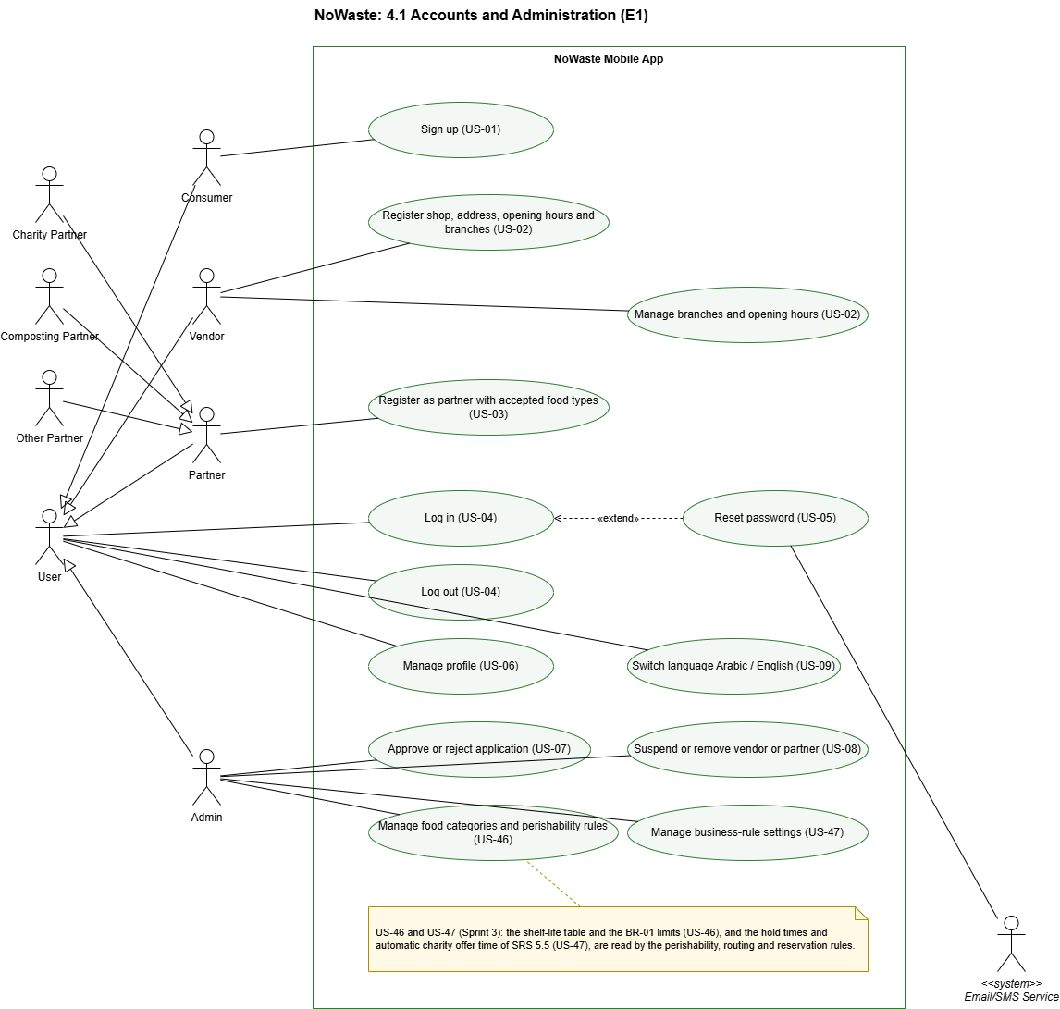

ID | Functional requirement | Priority | User Story
FR-ACC-01 | The system shall allow consumers to register using an email address or phone number. | High | US-01
FR-ACC-02 | The system shall allow formal and informal vendors to submit their shop information, the shop location as a map pin with a written address, the opening hours and any further branches (each with its own address, pin and opening hours) for administrator approval. A branch carries the shop name. | High | US-02
FR-ACC-03 | The system shall allow charity and composting partners and other partners that describe their type in writing to register, state the food types they accept (one or more of the six food categories, or another food type written in), and submit this for administrator approval. | High | US-03
FR-ACC-04 | The system shall allow registered users to log in and log out. | High | US-04
FR-ACC-05 | The system shall provide a password-reset mechanism for registered users. | High | US-05
FR-ACC-06 | The system shall allow registered users to update their profile and contact information. | Medium | US-06
FR-ACC-07 | The system shall allow administrators to approve or reject vendor and partner applications. | High | US-07
FR-ACC-08 | The system shall allow administrators to suspend or remove vendors or partners that violate platform policies. | High | US-08
FR-ACC-09 | The system shall allow any user, including before registration, to switch between Arabic and English. | High | US-09
FR-ACC-10 | The system shall allow administrators to manage the food categories and the perishability rules: the shelf-life of each food category in each storage condition and the BR-01 category limits. A change applies to listings saved after it. | High | US-46
FR-ACC-11 | The system shall allow administrators to change the business-rule settings of Section 5.5, such as the hold times and the automatic charity offer time, without a code change. | Medium | US-47
Error conditions
● E-ACC-01 If the email address or phone number is already registered, the system shall reject the registration and offer login or password reset.
● E-ACC-02 If the email or phone format is invalid or the password does not meet the password rules (at least 8 characters, with at least one letter and at least one digit), the system shall identify the invalid field and shall not create the account. A phone number is valid when it is an Egyptian mobile number: 11 digits starting with 010, 011, 012 or 015
● E-ACC-03 If invalid credentials are provided, the system shall reject authentication without revealing which credential was incorrect. Repeated failed attempts shall be rate-limited.
● E-ACC-04 If a password-reset code is incorrect or expired, the system shall reject it and allow the user to request a new one.
● E-ACC-05 If a vendor or partner whose application is Pending or Rejected logs in, the system shall show the application status and shall not allow posting or receiving food.
● E-ACC-06 Suspended accounts shall not be permitted to access protected functions. Removed accounts shall no longer have valid access credentials.
● E-ACC-07 If an administrator enters an invalid rule or setting value (for example an empty or negative shelf-life, or a Highly perishable limit that is not below the Short-life limit), the system shall identify the field and keep the previous value.

4.2 Listings

4.2.1 Description and Priority
The Listings feature covers:
● creating surplus food listings, including the simplified Quick Post for informal vendors
● AI classification of the food photo and the drafted listing
● the facts the vendor supplies that a photo cannot show (the food category and how the food is stored)
● administrator approval of every listing, including Quick Posts, before it is published
● editing, cancelling and viewing listings
● a suggested discount for listings that are not selling
● an estimated calorie range shown to consumers
Every AI result is a draft that the vendor accepts, edits or removes.
This feature has seven High-priority requirements, one Medium requirement (FR-LST-08) and one Low requirement (FR-LST-07).

4.2.2 Stimulus/Response Sequences
Create a listing
1. Vendor selects New listing and takes or uploads a photo → System compresses the image, sends it for AI classification and shows a draft with food type, category, quantity, and, when available, an estimated calorie range, plus a description in Arabic and English.
2. Vendor accepts or edits the draft (a name and description written in Arabic or English, shown as written) and enters the number of bags, original value, discounted price, the branch and the pickup start → System validates the values.
3. Vendor enters the food category and how the food is stored, or marks either as Unknown → System shows the allowed pickup window, from the pickup start to the pick-by time worked out in Section 4.3, with the estimated category as its reason. The vendor may choose an earlier pickup end.
4. Vendor saves the listing, chooses a destination (see 4.3) and publishes → System sends the listing to the administrator for approval; until then it is Pending review and not visible to anyone else.
5. Administrator opens the listings waiting for approval and approves one → System sets it to Active and makes it visible according to the routing choice (see 4.3). If the administrator rejects it, System tells the vendor the reason.
Quick Post (informal vendor)
1. Informal vendor selects Quick Post and takes a photo → System shows the AI draft.
2. Vendor enters a name and description, the number of bags, the price, optionally the food category, the pickup start (the time of posting unless the vendor chooses a later one) and the pickup end, and publishes → System assigns the listing a Highly perishable classification for perishability and routing purposes and sends it to the administrator for approval; it is published once approved.
3. After posting, the informal vendor sees the recommended destination and may send the Quick Post to a charity or composting partner instead, until the pickup ends (see 4.3).
Manage listings
1. Vendor opens My listings → System shows active and previous listings with their status and reservations.
2. Vendor edits or cancels an active listing → System saves the change and notifies consumers with reservations on it.
3. Bags are still unreserved as the pickup deadline nears → System suggests a discount, which increases as the deadline approaches. The vendor accepts or ignores it.
Alternative flows
● AI unavailable: the classification service fails or times out → System lets the vendor fill in the listing manually.
● Calorie estimate removed: Vendor removes the calorie range before publishing → System publishes the listing without it.

4.2.3 Functional Requirements

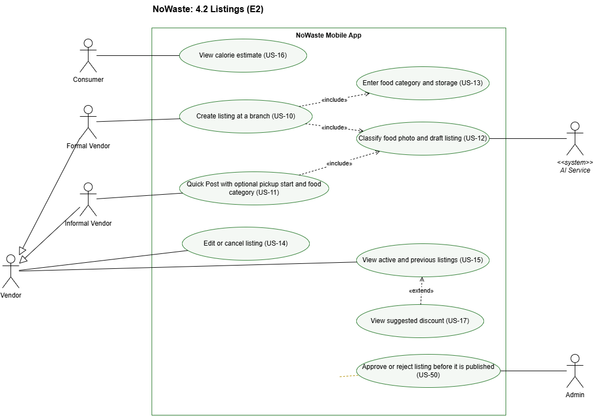
ID | Functional requirement | Priority | User Story
FR-LST-01 | The system shall allow formal vendors to create a listing with a photo, a name and description written once in Arabic or English and shown as written, the food category, storage, number of bags, original value, discounted price, the pickup start and the pickup location. The pickup location is one of the vendor's branches. The pickup end is worked out by the system (FR-RTE-01); the vendor may choose an earlier end. | High | US-10
FR-LST-02 | The system shall provide informal vendors with a Quick Post that asks only for a photo, a name and description, the number of bags, the price, an optional food category, an optional pickup start (the time of posting by default) and the pickup end time. The pickup location is the vendor's shop location. The pickup start shall be within the opening hours, and the pickup end no later than the Highly perishable limit (BR-01) after the start and no later than closing time. Quick Post listings shall be treated as Highly perishable for perishability and routing purposes. | High | US-11
FR-LST-03 | The system shall use the AI service to identify the food type, food category and estimated quantity from the uploaded photo and generate a draft listing in Arabic and English for the vendor to accept or edit.  Sprint 2 (D-81 to D-84): after choosing the photo the vendor taps "Fill in with AI draft"; the Arabic and English name and description are both stored once the vendor confirms or edits them; the estimated quantity is shown only as an Estimate and does not fill the number of bags. An AI category the vendor keeps with a confidence below the AI-CONFIDENCE setting counts as uncertain (NFR-05d). | High | US-12
FR-LST-04 | The system shall ask the vendor for the food category and how the food is stored (room temperature, chilled or frozen) for every listing except Quick Post. When either is unknown, the vendor shall be able to mark it as Unknown. Preparation time and expiry date are not asked; the pick-by time comes from the shelf-life rules (FR-RTE-01). | High | US-13
FR-LST-05 | The system shall allow vendors to edit or cancel their active listings. | High | US-14
FR-LST-06 | The system shall allow vendors to view their active and previous listings. | High | US-15
FR-LST-07 | The system shall generate an estimated calorie range from the listing photo when possible and display it to consumers labelled “Estimate”. The vendor shall be able to remove the estimate before publishing. | Low | US-16
FR-LST-08 | The system shall suggest a discount that increases as the pickup deadline approaches while bags remain unreserved. The vendor shall choose whether to apply the suggested discount. | Medium | US-17
FR-LST-09 | The system shall send every new listing, including Quick Posts, to the administrator for approval. The listing shall stay Pending review and shall not be visible to consumers or partners until the administrator approves it. The administrator shall be able to approve it, or reject it with a reason that is shown to the vendor. | High | US-50
Error conditions
● E-LST-01 If AI classification fails or takes longer than 10 seconds, the system shall let the vendor enter the listing details manually.
● E-LST-02 If the photo upload fails, the system shall keep the entered details and allow the vendor to retry.
● E-LST-03 If the proposed pickup end is later than the pick-by time worked out for the listing (FR-RTE-01), or, for a Quick Post, later than the Highly perishable limit after its start, the system shall reject it, show the latest allowed end and require an earlier end time.
● E-LST-04 If a required field is missing or invalid (for example, zero bags or a negative price or a discounted price higher than the original value), the system shall identify the field and shall not publish the listing. A pickup start or end outside the opening hours of the pickup branch is also invalid, and the system shall show the opening hours.
● E-LST-05 If a vendor cancels a listing that has active reservations, the system shall cancel those reservations, refund any card payments in full and notify the consumers.
● E-LST-06 If a vendor whose account is not approved attempts to create or publish a listing, the system shall refuse the action.
● E-LST-07 If the administrator rejects a listing, or its pickup window ends while it is still waiting for approval, the system shall not publish it and shall tell the vendor why.

4.3 Perishability and Routing

4.3.1 Description and Priority
The Perishability and Routing feature covers:
● estimating each listing's perishability category and pick-by time from the shelf-life rules
● recommending a destination for the surplus (consumers, charity, composting or landfill)
● showing consumers the most urgent food near them first
● donation pickups by charity partners, including automatic charity offers
● compost pickups for food that is unfit for people
● recording landfill disposal when no one can take the food
The perishability category is an estimate set when the listing is saved. The vendor sees it with what it means in hours; consumers see the pickup window. The system never certifies food as safe.
This feature has ten High-priority requirements and three Medium requirements (FR-RTE-11, FR-RTE-12 and FR-RTE-13).

4.3.2 Stimulus/Response Sequences
Perishability
1. Vendor saves the listing details (see 4.2) → System sets the estimated perishability category and the pick-by time.
2. Vendor wants the food collected sooner → Vendor chooses an earlier pickup end (see 4.2); the category is not changed by hand.
Routing
1. Vendor opens the saved listing → System ranks the possible destinations and shows the top recommendation.
2. Vendor chooses a destination → System sets the listing type: consumers make it a Discounted Surplus Bag, charity makes it a Donation, and composting makes it a Compost offer. Once the administrator approves the listing, it is shown to consumers or offered to the partners that accept its food type.
3. Vendor marks the food as unfit for people → System offers it only to composting partners.
Consumer view
1. Consumer opens nearby listings → System shows Highly perishable listings near the consumer first, then the other listings ranked by distance and time left in the pickup window, each with its pickup window.
Donation and compost pickups
1. Charity partner opens a Donation listing and proposes a pickup time → System validates the time, schedules the pickup, notifies the vendor and issues a pickup code.
2. Composting partner opens a Compost offer and proposes a pickup time → System schedules the pickup in the same way.
3. Vendor enters the pickup code at handover → System records the donation or compost pickup as completed (see 4.4).
Automatic charity offers
1. Vendor opts in to automatic charity offers → System saves the setting.
2. A Discounted Surplus Bag listing still has unreserved bags the number of minutes set by the administrator (TBD-5) before the pickup window ends → System offers those bags as a Donation to charity partners that accept the food type and notifies the vendor.
Alternative flows
● Nobody takes the food: the pickup window ends with no consumer, charity or composting partner taking the food → System asks the vendor to record a landfill disposal and records it for the impact numbers.
● Partner cancels: a partner cancels an accepted pickup → System offers the listing again to other eligible partners if time remains, or notifies the vendor.

4.3.3 Functional Requirements

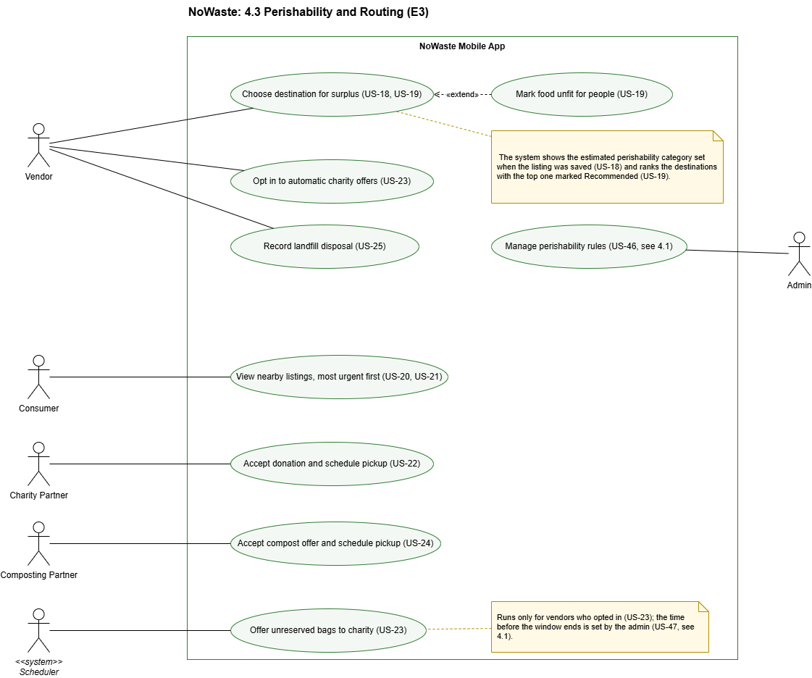

ID | Functional requirement | Priority | User Story
FR-RTE-01 | The system shall estimate a perishability category from the food category and storage condition of a listing. The food limit is the pickup start plus the shelf-life for that food category and storage condition, taken from rules the administrator manages (TBD-6, FR-ACC-10). The pick-by time (the latest pickup end) is the food limit, or the pickup start plus the Highly perishable limit when the shelf-life is not known, and never later than the closing time of the pickup branch. The category is based on the time from the pickup start, or from now once the pickup has started, to the food limit: Highly perishable (6 hours or less), Short-life (more than 6 and up to 48 hours) or Long-life (more than 48 hours). These categories represent pickup urgency and do not certify the food as safe. | High | US-18
FR-RTE-02 | The system shall assign the Highly perishable category when the food category or storage condition is marked Unknown, when no shelf-life is set for them, when the listing is a Quick Post, or when the AI estimate is uncertain. | High | US-18
FR-RTE-03 | The system shall set the estimated category when the listing is saved and show it to the vendor with what it means in hours. The vendor does not change the category; to have the food collected sooner, the vendor chooses an earlier pickup end. | High | US-18
FR-RTE-04 | The system shall show consumers each listing's pickup window (start and end) as the indication of how soon to collect. The perishability category is shown only to the vendor. | High | US-18
FR-RTE-05 | The system shall rank the possible destinations (consumers, charity, composting, landfill) using distance, time left, food category, and accepted food types and shall show the top recommendation. | High | US-19
FR-RTE-06 | The system shall set the listing type from the vendor's chosen destination: Discounted Surplus Bag for consumers, Donation for charity and Compost offer for composting. | High | US-19
FR-RTE-07 | The system shall allow the vendor to mark food as unfit for people. Such food shall be offered only to composting partners. | High | US-19
FR-RTE-08 | The system shall show Highly perishable listings near the consumer before other listings. | High | US-20
FR-RTE-09 | The system shall rank the other listings by distance and time left in the pickup window. | High | US-21
FR-RTE-10 | The system shall allow charity partners to accept Donation listings and schedule a pickup time within the pickup window. | High | US-22
FR-RTE-11 | The system shall allow vendors to opt in to automatic charity offers. For opted-in vendors, unreserved bags shall be offered as a Donation to eligible charity partners a number of minutes, set by the administrator (TBD-5, FR-ACC-11), before the pickup window ends. | Medium | US-23
FR-RTE-12 | The system shall offer Compost offers to composting partners that accept the food type and allow them to accept and schedule a pickup within the pickup window. | Medium | US-24
FR-RTE-13 | The system shall allow the vendor to record a landfill disposal when no consumer, charity or composting partner takes the food, and shall include it in the impact numbers. | Medium | US-25
Error conditions
● E-RTE-01 If the perishability estimate fails, the system shall assign the Highly perishable category and let the vendor continue.
● E-RTE-02 If the routing recommendation fails, the system shall let the vendor choose a destination from the eligible options without a recommendation.
● E-RTE-03 If a partner proposes a pickup time outside the pickup window, the system shall reject it and ask for another time.
● E-RTE-04 If a partner tries to accept a Donation or Compost offer that another partner has already accepted, the system shall refuse it and tell the partner it is no longer available.

4.4 Search, Reservation and Payment

4.4.1 Description and Priority
The Search, Reservation and Payment feature covers:
● browsing and filtering nearby offers on a map
● reserving a Discounted Surplus Bag, paying by card or reserving without a card with a time-limited hold
● a waitlist for listings whose bags are all reserved
● viewing reservations, for consumers and vendors
● confirming pickups with a 6-digit pickup code
● push notifications about reservations
● cancellations, refunds and no-show limits
Each consumer reservation reserves one bag from a listing. A consumer can have several active reservations at once, for different listings or pickup times.
This feature has eleven High-priority requirements and two Medium requirements (FR-RES-12 and FR-RES-13).

4.4.2 Stimulus/Response Sequences
Search
1. Consumer opens the map → System reads the device location (IF-HW-03) and shows the listings within the chosen distance (10 km by default, set with a slider from 1 to 50 km) as one pin per pickup branch and as a list that expands from the bottom of the screen, in the order described in Section 4.3. If location permission is denied, the System explains that nearby search needs the location and lets the consumer place a pin or type an address (IF-HW-04); until a location is available, the map shows offers around central Cairo.
2. Consumer taps a pin → System shows the store name, the branch address and that branch's offers. Consumer opens an offer → System shows the photo, name, food category, description, pickup window, bags left, and the original price struck through next to the discounted price.
3. Consumer filters by distance, price, pickup time or vendor rating → System updates the results.
Card reservation
1. Consumer selects a listing and chooses to pay by card → System sends the payment to the payment gateway.
2. Payment gateway approves the payment → System confirms the reservation, holds the bag for the whole pickup window, shows the pickup code and sends a confirmation notification.
No-card reservation
1. Consumer selects a listing and chooses to reserve without a card → System creates the reservation, starts a 45-minute hold from the later of the reservation time or the window start, capped at the window end, and shows the pickup code.
2. Consumer selects "I'm on my way" → System extends the hold once by 20 minutes, capped at the window end.
Pickup
1. Vendor opens the reservations for a listing → System shows each reservation and its status.
2. Vendor enters the pickup code the consumer shows → System marks the reservation as Completed.
Alternative flows
● Sold out: Consumer opens a listing marked Fully reserved → System offers a place on the waitlist.
● Bag released: a cancellation, no-show or expired hold releases a bag → If at least 30 minutes remain in the pickup window, System notifies the next consumer on the waitlist, who has 10 minutes to accept. Otherwise the bag returns to the vendor.
● Cancellation: Consumer cancels a reservation → System releases the bag, refunds a card payment in full if the cancellation is within 10 minutes of reserving, and records a no-show for a no-card reservation whose hold has started.

4.4.3 Functional Requirements

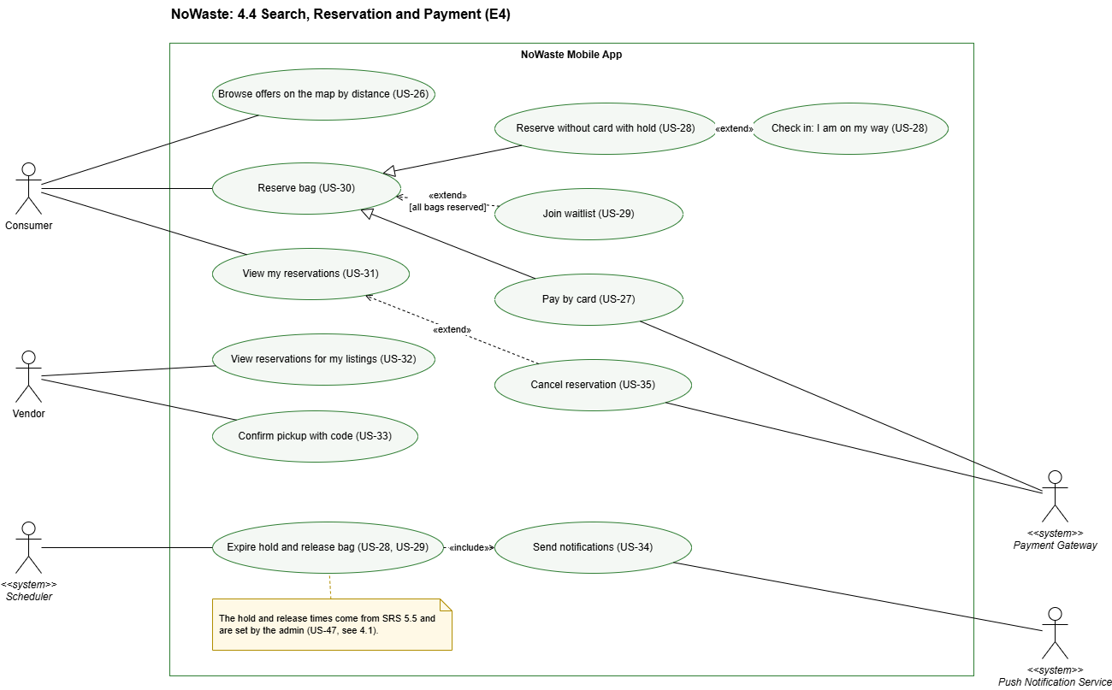

ID | Functional requirement | Priority | User Story
FR-RES-01 | The system shall allow consumers to browse offers on a map, where offers appear as pins at their pickup locations (one pin per branch), choose the search distance with a slider (10 km by default, 1 to 50 km), and filter them by price, pickup time and vendor rating. | High | US-26
FR-RES-02 | The system shall allow consumers to pay in full by card when reserving. The reservation shall be confirmed only after the payment gateway approves the payment, and the bag shall be held for the whole pickup window. | High | US-27
FR-RES-03 | The system shall allow consumers to reserve without a card. The bag shall be held for 45 minutes from the later of the reservation time or the pickup window start, and never past the window end. | High | US-28
FR-RES-04 | The system shall allow a consumer with a no-card reservation to check in once with "I'm on my way", extending the hold by 20 minutes, capped at the window end. | High | US-28
FR-RES-05 | The system shall release the bag when a hold expires without pickup. The bag shall be offered to the waitlist if at least 30 minutes remain in the pickup window; otherwise it shall return to the vendor. | High | US-28
FR-RES-06 | The system shall allow consumers to join a waitlist when all bags in a listing are reserved. When a bag is released, the next consumer shall be notified and have 10 minutes to accept it before it passes to the next person. When the consumer accepts, the system shall continue with the card or no-card reservation flow. | High | US-29
FR-RES-07 | The system shall not accept more reservations for a listing than it has bags. | High | US-30
FR-RES-08 | The system shall allow consumers to view their current and previous reservations, including the pickup code for active reservations. | High | US-31
FR-RES-09 | The system shall allow vendors to view the reservations for their listings and their status. | High | US-32
FR-RES-10 | The system shall generate a 6-digit pickup code for each consumer reservation and mark it as Completed when the vendor enters the valid code. The system shall use the same pickup-code confirmation for Donation and Compost pickups described in Section 4.3. | High | US-33
FR-RES-11 | The system shall send consumers push notifications when a reservation is confirmed, when their reservation is released, when a waitlisted bag is offered to them, and when the bag is ready because the pickup window opens. | High | US-34
FR-RES-12 | The system shall allow consumers to cancel a reservation before pickup. A card reservation shall be refunded in full only if cancelled within 10 minutes of reserving. | Medium | US-35
FR-RES-13 | The system shall count a no-show when a no-card hold expires without pickup or is cancelled after it has started. After 3 no-shows within 30 days, the system shall block the consumer from no-card reservations for 14 days. | Medium | US-35
Error conditions
● E-RES-01 If the card payment fails or is declined, the system shall not create the reservation and the bag shall remain available.
● E-RES-02 If two consumers try to reserve the last bag at the same time, the system shall accept only the first and offer the other the waitlist.
● E-RES-03 If the vendor enters an invalid pickup code, or the code belongs to an expired or cancelled reservation, the system shall not complete the reservation.
● E-RES-04 If a blocked consumer tries to reserve without a card, the system shall refuse it, show when the block ends and allow card payment instead.
● E-RES-05 If the consumer tries to check in a second time or after the hold has expired, the system shall refuse the check-in.
● E-RES-06 If the connection drops, the system shall still show the consumer their active reservations and pickup codes as last loaded.

4.5 AI Assistant

4.5.1 Description and Priority
The AI Assistant feature covers:
● finding food by typing or speaking in Arabic or English
● answering questions and reading the answers aloud
● reserving through the assistant, only after the user confirms
● helping vendors understand how to post listings and check their reservations
The assistant is an additional way to use the app. It follows the same rules as the screens in Sections 4.2 and 4.4, and it never completes a reservation without the user's confirmation. Card payments are always completed on the normal payment screen.
This feature has three Medium-priority requirements and one Low requirement (FR-AST-04).

4.5.2 Stimulus/Response Sequences
Find food
1. Consumer opens the assistant and types or speaks a request in Arabic or English, for example "bread near me for under 50 pounds" → System converts speech to text, interprets the request and shows the matching listings.
2. Consumer asks a question, for example "When does the pickup end?" → System answers in the consumer's language and reads the answer aloud if the consumer chooses.
Reserve through the assistant
1. Consumer asks to reserve a listing → System repeats the vendor, food, price, pickup window and reservation method and asks the consumer to confirm.
2. Consumer confirms → System continues with the selected reservation flow described in Section 4.4. For a no-card reservation, System creates the hold and shows the pickup code. For card payment, System opens the normal payment screen and confirms the reservation only after successful payment.
Vendor help
1. Vendor asks how to post a listing or asks to see their reservations → System explains the steps or shows the reservations.
Alternative flows
● Not understood: the assistant cannot understand the request → System asks the user to repeat or rephrase it, or to type it.
● Consumer does not confirm: Consumer says no or cancels → System does not reserve and keeps the conversation open.

4.5.3 Functional Requirements

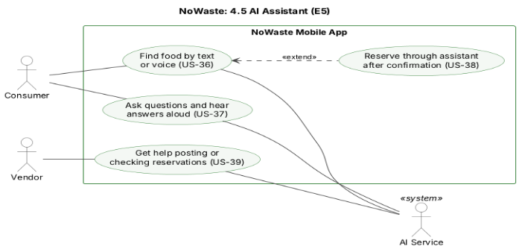

ID | Functional requirement | Priority | User Story
FR-AST-01 | The system shall allow consumers to search for food by typing or speaking to the assistant in Arabic or English, and shall show the same results as the equivalent search on the map. | Medium | US-36
FR-AST-02 | The system shall allow consumers to ask the assistant questions about listings and their reservations, and shall read the answers and results aloud when the consumer chooses. | Medium | US-37
FR-AST-03 | The system shall allow consumers to initiate a bag reservation through the assistant. The assistant shall repeat the selected listing, price, pickup window and reservation method and shall proceed only after the consumer confirms. No-card reservations shall follow the no-card flow in Section 4.4. If card payment is selected, the system shall redirect the consumer to the normal payment screen, where the reservation is confirmed only after successful payment. | Medium | US-38
FR-AST-04 | The system shall allow vendors to ask the assistant how to post a listing and to check the reservations for their listings. | Low | US-39
Error conditions:
● E-AST-01 If a request matches more than one listing, the system shall show the options and ask the consumer to choose, and shall not choose one itself.
● E-AST-02 If the AI service is unavailable, the system shall tell the user and let them search and reserve through the normal screens.

4.6 Trust, Giving and Impact

4.6.1 Description and Priority
The Trust, Giving and Impact feature covers:
● ratings and reviews of vendors after a completed pickup
● no-show flags by vendors and automatic flagging of unreliable accounts for the administrator
● reports of bad bags by consumers, reviewed by the administrator
● donating a paid bag to a charity partner as Zakat, with a traceable receipt
● impact numbers for every user
● a Ramadan mode for iftar and suhoor surplus
This feature has five High-priority requirements, four Medium requirements (FR-TGI-04 to FR-TGI-07) and one Low requirement (FR-TGI-08).

4.6.2 Stimulus/Response Sequences
Ratings
1. A reservation is marked Completed → System asks the consumer to rate the vendor.
2. Consumer gives 1 to 5 stars and an optional review → System saves the rating and updates the vendor's average rating shown on its listings.
No-shows
1. The pickup window ends and a reservation is not Completed → Vendor flags the consumer as a no-show → System records the no-show.
2. A consumer reaches 3 no-shows within 30 days → System flags the account for the administrator.
3. Administrator reviews the flagged account → Administrator takes no action, warns the consumer or suspends the account (see 4.1).
Bad-bag reports
4. Consumer reports a Completed bag as spoiled or not as described, with a short reason and an optional photo → System records the report and notifies the administrator.
5. Administrator reviews the report → Administrator takes no action, warns the vendor or suspends the vendor (see 4.1).
Zakat donation
1. Consumer selects a Discounted Surplus Bag listing and chooses Donate as Zakat → System shows the charity partners that accept the food type.
2. Consumer chooses a charity partner and pays by card → System reserves the bag, turns it into a Donation for that charity partner and issues a receipt.
3. Charity partner collects the bag with the pickup code (see 4.3 and 4.4) → System updates the receipt to show that the donation was delivered.
Impact and Ramadan mode
1. Any user opens the impact screen → System shows the platform-wide impact numbers and the user's own.
2. Consumer turns on Ramadan mode → System highlights listings whose pickup windows fall before iftar or suhoor.
Alternative flows
● Zakat donation not collected: the chosen charity partner does not collect the bag before the pickup window ends → System refunds the consumer in full and updates the receipt.

4.6.3 Functional Requirements

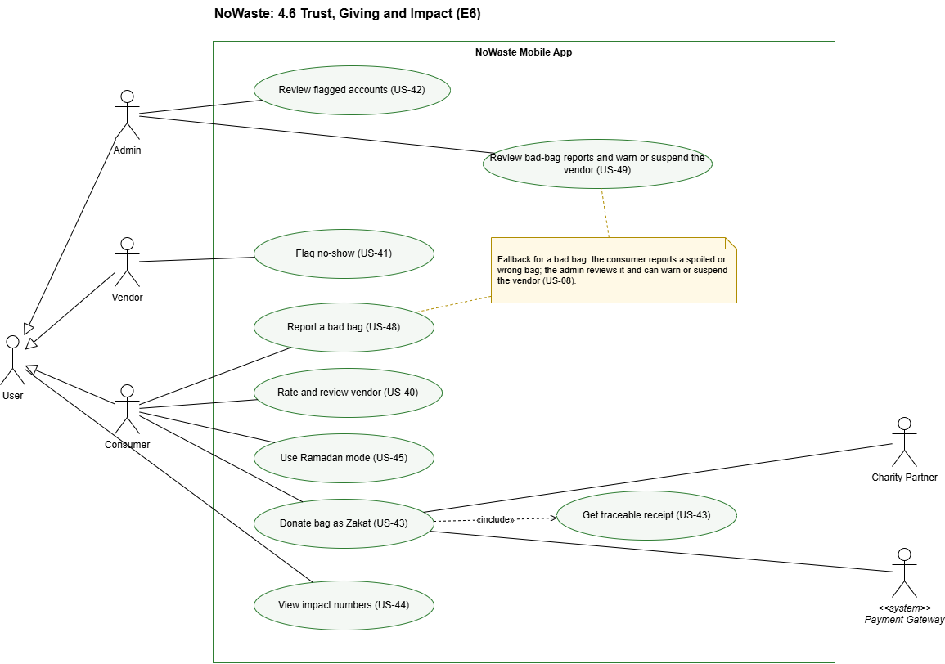

ID | Functional requirement | Priority | User Story
FR-TGI-01 | The system shall allow a consumer to rate a vendor from 1 to 5 stars, with an optional written review, once for each Completed reservation. | High | US-40
FR-TGI-02 | The system shall show each vendor's average rating and reviews on its listings. | High | US-40
FR-TGI-03 | The system shall allow vendors to flag a consumer as a no-show for a reservation that was not Completed by the end of the pickup window. | High | US-41
FR-TGI-04 | The system shall automatically flag for administrator review any consumer account that reaches 3 no-shows within 30 days, counting both vendor-flagged no-shows and those recorded under FR-RES-13. | Medium | US-42
FR-TGI-05 | The system shall allow consumers to pay by card for a bag and donate it as Zakat to a charity partner that accepts the food type. The bag shall become a Donation collected by that charity partner. | Medium | US-43
FR-TGI-06 | The system shall issue a traceable receipt for each Zakat donation showing the vendor, food, amount, charity partner and date, and shall update it when the charity partner collects the bag. | Medium | US-43
FR-TGI-07 | The system shall show every user impact numbers: meals rescued, money saved, estimated CO2 avoided, and the number of bags composted and sent to landfill, both platform-wide and for the user's own account. | Medium | US-44
FR-TGI-08 | The system shall provide a Ramadan mode that highlights listings whose pickup windows fall before iftar or suhoor. | Low | US-45
FR-TGI-09 | The system shall allow a consumer to report a Completed reservation whose bag was spoiled or not as described, once per reservation, with a short reason and an optional photo. | High | US-48
FR-TGI-10 | The system shall show administrators the bad-bag reports with the vendor, listing and reason, and shall allow them to take no action, warn the vendor or suspend the vendor (FR-ACC-08). | High | US-49
Error conditions
● E-TGI-01 If a vendor tries to flag a no-show before the pickup window ends, for a completed reservation, or a second time for the same reservation, the system shall refuse it.
● E-TGI-02 If the Zakat payment fails, the system shall not reserve the bag or create the donation.
● E-TGI-03 If the charity partner does not collect a Zakat donation before the pickup window ends, the system shall refund the consumer in full and record this on the receipt.
● E-TGI-04 If a consumer reports a reservation that is not Completed, or reports the same reservation a second time, the system shall refuse it.

5. Other Nonfunctional Requirements
The 15 nonfunctional requirements are NFR-01 to NFR-15. A letter after a number (NFR-05a) splits a requirement into single statements, and a citation of NFR-05 elsewhere in this SRS means all its parts. Every requirement has a verification method. Section 5.5 defines each timing and limit once, as a business rule.

5.1 Performance Requirements
Many users are on mobile data and some are on slow connections. NoWaste cannot control the network, so the limits below cover what the product controls (payload and photo size and response time) and are verified on a simulated Fast 3G connection.

ID | Requirement | Verification
NFR-01 | A search for listings within 10 km of the user shall return results in under 2 seconds. | 20 timed searches on a database of 500 listings; at least 19 take under 2 seconds.
NFR-02 | The system shall return an AI draft listing within 10 seconds after the photo upload completes. | 20 test photos; at least 18 return a draft within 10 seconds.
NFR-08a | The app shall compress each photo to 500 KB (500 × 1024 bytes) or less before upload. | Upload a 5 MB photo and check the size sent.
NFR-08b | The browse and listing-detail screens shall load within 5 seconds on a simulated Fast 3G connection. | 10 loads under emulator network throttling; all within 5 seconds.

5.2 Safety Requirements
The harm to prevent is a person eating food that has spoiled. NoWaste estimates how urgently food should be collected, and it never certifies that food is safe.

ID | Requirement | Verification
NFR-05a | The app shall never state or imply that food is safe to eat, and shall label every AI-derived value as an estimate or a draft. | Review every screen that shows AI output.
NFR-05b | A listing shall not be published until the vendor has confirmed or edited every AI-filled field. | Test: publishing with an unconfirmed field is refused.
NFR-05c | A pickup window shall end no later than the pick-by time worked out from the shelf-life rules and the closing time of the pickup branch (FR-RTE-01, E-LST-03). | Test: a window that ends after the pick-by time is refused.
NFR-05d | When the storage condition or food category is Unknown, no shelf-life is set for them, or the AI estimate is uncertain, the system shall assign the Highly perishable category (FR-RTE-02). | Test with four listings, each missing a different one of these inputs.

5.3 Security Requirements
The product handles accounts, locations and card payments. Security and privacy rules apply to all roles.

ID | Requirement | Verification
NFR-09a | All traffic between the app and the backend shall use HTTPS. | A plain HTTP request is refused.
NFR-09b | Passwords shall be stored only as salted hashes. | Inspect the database and review the code.
NFR-09c | A request made with one role’s access token shall receive HTTP 403 on another role’s endpoints. | Automated test for every pair of roles: consumer, vendor, partner, administrator.
NFR-09d | After 5 failed login attempts on an account within 15 minutes, the system shall refuse further logins to that account for 15 minutes (E-ACC-03). | Test: 5 wrong passwords, then a correct one within 15 minutes is refused.
NFR-10 | Card details shall be handled only by the payment gateway and shall never be stored by NoWaste. | Inspect the database and logs after a sandbox payment.
NFR-11a | A consumer’s device location shall be used only in search and ranking requests and shall not be stored. | Inspect server logs and the database after a search.
NFR-11b | A voice recording shall be deleted after it has been processed. | After a voice request, check that no audio is stored.

5.4 Software Quality Attributes
Where attributes conflict, the order of preference is food safety, then security and privacy, then correct reservations (no double booking), then speed and ease of use.

ID | Attribute | Requirement | Verification
NFR-03 | Availability (fault tolerance) | With the AI service unavailable, a vendor shall still be able to publish a listing by hand, and a consumer shall still be able to search and reserve. | Run the end-to-end demo with the AI credentials removed.
NFR-12 | Availability | When the payment gateway, the map service, the push notification service or the email and SMS service is unavailable, the functions that do not depend on it shall continue to work. | Switch each service off in turn and run the functions that do not use it.
NFR-08c | Availability (fault tolerance) | During a temporary loss of connection, the app shall keep showing the details and pickup code of an active reservation as last loaded (E-RES-06). | Load a reservation, switch the device to airplane mode, and open it.
NFR-15 | Reliability | The same listing inputs and rule values shall always give the same perishability category, pick-by time and destination ranking, and a reservation or payment request repeated after a dropped connection shall never create a second reservation or payment. | Automated tests: repeated estimates give identical results; a reservation request sent twice with the same key creates one reservation.
NFR-04 | Accuracy | The food classifier shall assign the correct category to at least 80% of 60 labelled test photos: 10 for each of the six categories, at least 30 of them Egyptian dishes or baked goods. | Run the classifier on the set and keep the accuracy result.
NFR-06 | Usability | Every screen shall display correctly right-to-left in Arabic and left-to-right in English, with no clipped or overlapping text. | Screen-by-screen checklist in both languages on one phone.
NFR-07a | Accessibility | The sign-up, browse and reserve flows shall be fully operable with TalkBack on Android and VoiceOver on iOS. | Walk through the three flows with each screen reader.
NFR-07b | Accessibility | Text on every screen shall have a contrast ratio of at least 4.5:1 against its background. | Accessibility scanner report with no contrast failures.
NFR-13 | Maintainability | Every merge to the main branch shall run the automated tests on GitHub Actions and require one approving code review. | Branch protection is on, and a failing test blocks a merge.
NFR-14 | Portability | The app shall run on Android and iOS from one shared codebase (minimum versions: Appendix C, TBD-1). | Install the app and run the demo script on one Android and one iOS device or emulator.

5.5 Business Rules

ID | Rule | Source
BR-01 | Perishability: Highly perishable ≤ 6 h, Short-life > 6 h to 48 h, Long-life > 48 h, counted from the pickup start to the food limit; the limits and the shelf-life values are kept in the database and managed by the administrator (FR-ACC-10) | FR-RTE-01
BR-02 | No-card hold: 45 minutes from the later of reservation time or window start, capped at window end | FR-RES-03
BR-03 | One "I'm on my way" check-in: +20 minutes, capped at window end | FR-RES-04
BR-04 | A released bag goes to the waitlist only if at least 30 minutes remain | FR-RES-05
BR-05 | Waitlist offer: 10 minutes to accept | FR-RES-06
BR-06 | Card refund: full refund only if cancelled within 10 minutes of reserving | FR-RES-12
BR-07 | No-show limit: 3 no-shows in 30 days blocks no-card reserving for 14 days | FR-RES-13
BR-08 | Admin flag: 3 no-shows in 30 days flags the account | FR-TGI-04
BR-09 | Pickup code: 6 digits | FR-RES-10
BR-10 | Automatic charity offer: (TBD-5) minutes before window end | FR-RTE-11
BR-11 | Uncollected Zakat donation: full refund | FR-TGI-05, E-TGI-03
BR-12 | AI draft time limit: 10 seconds | E-LST-01, NFR-02

6. Other Requirements

6.1 Global, Cultural, Social, Environmental, Economic, Public Health, Safety and Public welfare
NoWaste's requirements address the global, cultural, social, environmental, economic, public health, safety and public welfare issues of food waste in Egypt. The table shows, for each area, the problem, how the product responds and the requirements that implement the response.
Area | Issue | How NoWaste addresses it | Requirements
Global | Roughly a third of the world's food is wasted. UN SDG 12.3 sets a target to halve food waste by 2030. | Sends surplus food to people first and measures the bags rescued. The app works on Android and iOS in two languages. | FR-RTE-05, FR-TGI-07, FR-ACC-09, NFR-14
Cultural | Egyptian users speak Arabic, many vendors are informal street stalls and bakeries, and giving follows Zakat and Ramadan customs. | Full Arabic with right-to-left screens, a voice assistant that understands Arabic, Quick Post for informal vendors, Zakat donations with a receipt, and a Ramadan mode for iftar and suhoor. | FR-ACC-09, NFR-06, FR-AST-01, FR-AST-02, FR-LST-02, FR-TGI-05, FR-TGI-06, FR-TGI-08
Social | Many students and low-income households have no payment card, and some users have low literacy or a disability. | Reservation without a card (paid at pickup), donations to charity partners, a voice assistant that reads answers aloud, and screens usable with TalkBack and VoiceOver. | FR-RES-03, FR-RTE-10, FR-RTE-11, FR-AST-02, NFR-07
Environmental | Food sent to landfill releases methane, and food unfit for people is still thrown away. | Routing to consumers, then charity, then composting, with landfill only as a last resort. Unfit food goes only to composting partners. Landfill disposals are recorded and shown in the impact numbers, along with estimated CO2 avoided. | FR-RTE-05, FR-RTE-06, FR-RTE-07, FR-RTE-12, FR-RTE-13, FR-TGI-07
Economic | Vendors lose the money spent on unsold food, and households face high food prices. | Vendors sell surplus at a discount, with a suggested discount that rises near the deadline. Consumers see the money they saved. Quick Post lets small vendors take part. Small photos and payloads keep mobile data costs low. | FR-LST-01, FR-LST-02, FR-LST-08, FR-RES-01, FR-TGI-07, NFR-08
Public health | Eating spoiled food causes illness. | Perishability categories show how urgently food should be collected and never certify it as safe. The pickup window cannot pass the pick-by time worked out from the shelf-life rules. Missing information defaults to Highly perishable. The most urgent food is shown first. Calorie ranges are labelled as estimates. Consumers can report a bad bag, and the administrator can warn or suspend the vendor. | FR-RTE-01 to FR-RTE-04, FR-RTE-08, FR-LST-04, FR-LST-07, E-LST-03, NFR-05, FR-TGI-09, FR-TGI-10
Safety | Unknown vendors, wrong collections and misuse of payment data put users at risk. | Every vendor and partner is approved by an administrator and can be suspended. Each pickup needs a 6-digit code. Card data stays with the payment gateway, and passwords are stored as salted hashes. | FR-ACC-02, FR-ACC-03, FR-ACC-07, FR-ACC-08, FR-RES-10, NFR-09, NFR-10
Public welfare | Users need fair access, trust in other users and protection of their personal data. | Bags are never over-reserved, and a waitlist gives released bags to the next person. Ratings and no-show limits build trust. Zakat receipts make donations traceable. Location is not stored, and voice recordings are deleted after processing. Core functions keep working without AI. | FR-RES-06, FR-RES-07, FR-RES-13, FR-TGI-01 to FR-TGI-04, FR-TGI-06, NFR-03, NFR-11

6.2 Implementation Scope and Risk Analysis

6.2.1 Implementation Scope
The SRS backlog has 50 stories (184 points). Priority records importance (SRS 1.2); the scope below is decided separately, so some High-priority stories are negotiable and some Low-priority stories are non-negotiable.
Non-negotiables: 38 stories, 149 points. We will build all of these by 1 December. They are the stories the core flow needs (a vendor posts food, a consumer finds it, reserves it and collects it with a code), plus: the AI assistant, the waitlist, Zakat, the calorie range, impact numbers, Ramadan mode, and the administrator's work (listing approval, perishability rules, settings, bad-bag reports, suspension and flagged accounts).
Negotiables: 11 stories, 32 points. We will build these in the order below only if the non-negotiables are on track. Each has a working fallback, given in brackets.
Deferred: 1 story, 3 points. Not planned for this semester.

Non-negotiables (149 points)
Area | Stories | Points
Accounts | US-01 Consumer registration (3), US-02 Vendor application (3), US-03 Partner application (2), US-04 Log in/out (5), US-07 Approve/reject (3), US-09 Arabic/English RTL (5), US-08 Suspend or remove accounts (3), US-46 Manage perishability rules (3), US-47 Manage business-rule settings (2) | 29
Listings | US-10 Create listing (5), US-11 Quick Post (2), US-12 AI draft (8), US-13 Food category and storage (2), US-16 Calorie range (3), US-50 Approve listings before publishing (3) | 23
Perishability and routing | US-18 Category and urgency (5), US-19 Destination recommendation (5), US-20 Highly perishable first (3), US-21 Rank by distance/time (2), US-22 Charity pickup (5) | 20
Search and reservation | US-26 Map search/filters (5), US-27 Card reservation (8), US-28 No-card hold and check-in (8), US-29 Waitlist (5), US-30 No over-reservation (3), US-31 My reservations (3), US-32 Vendor reservations (2), US-33 Pickup code (3), US-35 Cancellation, refund, no-show limit (5) | 42
AI assistant | US-36 Typed search (5), US-37 Answers read aloud (5), US-38 Reserve through the assistant (5) | 15
Giving and impact | US-43 Zakat donation and receipt (8), US-44 Impact numbers (3), US-45 Ramadan mode (2), US-42 Automatic flag for the administrator (2), US-48 Report a bad bag (2), US-49 Review bad-bag reports (3) | 20

Negotiables (32 points, in this order)
1. US-34 Push notifications (5) – [offers and statuses stay visible in the app]
2. US-40 Ratings and reviews (3)
3. US-41 Vendor flags a no-show (2)
4. US-14 Edit or cancel a listing (5) – [vendor posts a new listing instead]
5. US-15 View my listings (2) – [vendor sees reservations through US-32]
6. US-06 Profile (2)
7. US-25 Landfill record (1)
8. US-24 Compost offers (3) – [reuses the partner flow of US-22]
9. US-05 Password reset (3) – [the team resets passwords by hand]
10. US-17 Suggested discount (3) – [vendor sets the price by hand]
11. US-23 Automatic charity offers (3)

Deferred (3 points)
US-39 Assistant help for vendors (3) – Low priority; vendors use the normal screens.
The assistant (US-36 to US-38) and Zakat (US-43) are non-negotiable but are built last, in Sprint 3, because they have the most new external dependencies. They are the first to move if the team falls behind (see the re-planning rule).
The administrator stories added after the Sprint 1 feedback (US-46 to US-50, with US-08 and US-42 moved up from the negotiables) are built in Sprint 3.
The nonfunctional requirements (NFR-01 to NFR-15) apply to every non-negotiable story and are part of its definition of done.

6.2.2 Feasibility
We assume about 10 points per member per sprint, so about 50 per sprint and 150 in three sprints. The non-negotiables use 149 points (99%), which leaves about 1 point for bugs, reviews, testing against the NFRs and estimation errors. This is tight, and the capacity is an assumption until Sprint 1 is measured.
Sprint | Dates (2026) | Goal | Stories | Points
Setup | 12–18 Oct | Jira, GitHub, CI, skeletons, schema, AI and payment sandbox tests | – | –
1 | 19 Oct – 1 Nov | Accounts, approval, Arabic/English, listings without AI, perishability, routing | US-01 to 04, 07, 09, 10, 11, 13, 18, 19 | 40
2 | 2 – 15 Nov | AI draft, map search, card and no-card reservations, pickup code, reservation views | US-12, 20, 21, 26, 27, 28, 30, 31, 32, 33 | 45
3 | 16 – 29 Nov | Waitlist, cancellation, charity pickup, Zakat, AI assistant, calorie range, impact, Ramadan mode, administrator listing approval, rules, settings, bad-bag reports, suspension and flagged accounts | US-08, 16, 22, 29, 35, 36, 37, 38, 42, 43, 44, 45, 46, 47, 48, 49, 50 | 64
Buffer | 30 Nov – 1 Dec | Bug fixing, demo data, release build, backup video | – | –
Why this fits:
● Order follows dependencies: accounts and listings first, reservations second, features that react to reservations third.
● A pickup code can be shown and entered by the end of Sprint 2, so the Sprint 2 demo shows the full main flow.
● Every external service sits behind an adapter that can be mocked, so members work in parallel; every AI feature has a manual fallback (NFR-03).
Re-planning rule: at the end of each sprint we compare completed and planned points. If Sprint 1 delivers fewer than 35 points or Sprint 2 fewer than 40, these stories become negotiable, in this order, until the plan fits: US-37, US-38, US-36, US-45, US-16, US-44.
Sprint 1 also delivered US-15 (View my listings) and the map part of US-26 early, at the team's request after phone testing. Sprint 3 now has 64 points, more than the assumed 50; if it does not fit, the re-planning rule above applies.

6.2.3 Risks
Likelihood and impact: High (H), Medium (M), Low (L).
# | Risk | L | I | Mitigation
1 | Stories take longer than estimated | M | H | Commit 87% of capacity; re-plan after each sprint; assistant, calorie range, impact and Ramadan mode move first
2 | Availability drops during midterms and other deadlines | H | M | Lighter load in exam weeks; each story has an owner and a backup; weekly check-in
3 | Late integration and merge conflicts | M | H | Small pull requests; CI on every merge; run main flows weekly
4 | New technologies (React Native, PostGIS, payment SDK) | M | M | Learning spikes in setup week; pair programming; code review
5 | External services (AI, payment, push) behave differently or hit limits | M | H | Adapters with timeouts, fallbacks and mock mode; sandbox tested in setup week; keep no-card flow as fallback
6 | Two users reserve the last bag at once | M | H | Database transaction with a row lock; concurrent-request tests
7 | Timers (hold, waitlist) missed or duplicated after a restart | M | H | Expiry times stored in the database; worker processes idempotently; restart tests
8 | AI classification below 80% or wrong about perishability | M | H | Vendor confirms every draft; default to Highly perishable; early test on labelled photos
9 | Slow connection (Fast 3G) causes failed uploads | H | M | Compress photos on device; small payloads; retries; cache active reservations
10 | Demo fails because a service is down or over its free limit | M | H | Mock mode; seeded demo data; recorded backup video
11 | Assistant (LLM, Arabic speech) and Zakat (second payment flow) arrive late with new dependencies | M | H | Built last in Sprint 3 on existing adapters; typed input before speech; Zakat reuses US-27, US-35 and US-22; first to move if behind

6.2.4 User Interface Overview
NoWaste is one React Native app for Android and iOS. After login it opens the home screen of the user's role, and each role sees only its own screens. Every screen is available in Arabic (right to left) and English. All roles share language switching, login, password reset and a profile with log out. Errors appear next to the field that failed, and the app asks for confirmation before actions that cannot be undone.
● Consumer: map and list of nearby listings, with Highly perishable food first and filters; listing details with price, bags left, pickup window and calorie range (labelled as an estimate); reserve by card or without a card, with a hold countdown, and a waitlist for full listings; my reservations with the 6-digit pickup code and cancel; Donate as Zakat with a receipt; AI assistant for typed or spoken search, answers read aloud and reserving after confirmation; impact numbers and Ramadan mode.
● Vendor: application status; new listing with AI draft (manual form if AI fails) and Quick Post; allowed pickup window before saving; destination screen with the estimated category; branches and opening hours; reservations with pickup code entry.
● Charity and composting partner: offers matching the accepted food types; accept and propose a pickup time; pickup code.
● Administrator: pending applications with approve and reject; listings waiting for approval; suspend or remove accounts; flagged accounts and bad-bag reports; perishability rules and business-rule settings.
Negotiable features (push notifications, ratings, no-show flags, listing edit and cancel, my listings, profile, password reset, compost offers, and others) appear only if built.

Appendix A: Glossary
Term | Definition
Administrator | A team-created account that approves, rejects, suspends or removes vendors and partners, approves listings before they are published, reviews flagged accounts and bad-bag reports, and manages the perishability rules and business-rule settings.
Automatic charity offer | An opt-in vendor setting that offers unreserved bags as a Donation to charity partners (TBD-5) minutes before the pickup window ends.
Bad-bag report | A consumer's report that a collected bag was spoiled or not as described, reviewed by the administrator.
Branch | One of a vendor's pickup places, with its own address, map pin and opening hours. It carries the shop name; the first branch is the shop itself.
Charity partner | An approved organisation that accepts Donation listings and collects them with a pickup code.
Compost offer | A listing offered only to composting partners, for food that is unfit for people or that no one else takes.
Composting partner | An approved organisation that collects food for composting.
Discounted Surplus Bag | A listing sold to consumers at a discount. Each reservation is for one bag.
Donation | A listing given free to a charity partner.
Food category | One of six groups the AI assigns from the photo: bread and baked goods; cooked meals; fruit and vegetables; dairy and eggs; meat, poultry and fish; packaged and dry food.
Formal vendor | A registered business, such as a restaurant or grocery chain, that posts full listings at one of its branches.
Hold | The time a no-card reservation keeps a bag: 45 minutes, extended once by 20 minutes with "I'm on my way", never past the window end.
Impact numbers | Meals rescued, money saved, estimated CO2 avoided, and bags composted or sent to landfill, shown platform-wide and per user.
Informal vendor | An unregistered seller, such as a street stall or small bakery, that uses Quick Post.
Listing | A vendor's post of surplus food, with a photo, a name and description, number of bags, price, pickup branch and pickup window.
Listing type | Discounted Surplus Bag, Donation or Compost offer, set by the destination the vendor chooses.
Money saved | The original value minus the price paid, for listings that have an original value.
No-show | A reservation not collected: a no-card hold that expires or is cancelled after it starts, or a reservation the vendor flags after the pickup window.
Original value | The normal price of the food in a bag, entered by the vendor and used for the discount and money saved.
Perishability category | An estimate of pickup urgency, set when a listing is saved from its food category and storage and shown only to the vendor: Highly perishable (6 hours or less), Short-life (over 6 up to 48 hours) or Long-life (over 48 hours). It does not certify that food is safe.
Pick-by time | The latest pickup end of a listing: the pickup start plus the shelf-life, never later than the closing time of the pickup branch.
Pickup code | A 6-digit code that the vendor enters at handover to mark a reservation, donation or compost pickup as Completed.
Pickup window | The start and end time during which food can be collected. It cannot end after the pick-by time.
Quick Post | A short listing form for informal vendors that asks only for a photo, a name and description, number of bags, price, an optional food category and the pickup time. It is always Highly perishable.
Ramadan mode | A consumer setting that highlights listings whose pickup windows fall before iftar (the sunset meal) or suhoor (the pre-dawn meal).
Routing recommendation | The destination (consumers, charity, composting or landfill) the system ranks first for a listing. The vendor makes the final choice.
Shelf-life | The number of hours food of one food category keeps in one storage condition (room temperature, chilled or frozen), kept in a rules table that the administrator manages.
Waitlist | A queue for a fully reserved listing. A released bag is offered to the next consumer, who has 10 minutes to accept.
Zakat | An obligatory Islamic charitable payment. In NoWaste, a consumer pays for a bag that is then donated to a charity partner, with a traceable receipt.

Appendix C: To Be Determined List
ID | Open item | Where it is cited | Needed before
TBD-1 | Minimum supported Android and iOS versions | 2.4, 3.2, NFR-14 | Start of implementation
TBD-2 | Partly closed: the backend is Node.js with TypeScript and Express, and the app is Expo React Native with TypeScript. The service providers are still open.  Sprint 2 (2026-11-09, D-85): the AI vision service is Groq's hosted open-weight model qwen/qwen3.8-27b, called from the backend through Groq's OpenAI-compatible API with a key kept only on the server (IF-SW-01). It is the development provider; the final choice waits for the NFR-02 and NFR-04 measurements. The providers of the payment gateway, map tiles, push notifications, email and SMS, the language model and speech are still open. | 2.4, 3.3 | Start of implementation
TBD-5 | How many minutes before the pickup window ends the automatic charity offer is made | FR-RTE-11, 4.3.2, BR-10 | Implementing automatic charity offers
TBD-6 | The shelf-life of each food category in each storage condition (FR-RTE-01). Proposed values in use, waiting for team approval (hours at room temperature / chilled / frozen): bread and baked goods 48 / 120 / 720; cooked meals 2 / 72 / 720; fruit and vegetables 48 / 120 / 720; dairy and eggs 2 / 120 / 720; meat, poultry and fish 2 / 24 / 720; packaged and dry food 720 / 720 / 720. The administrator will manage them (FR-ACC-10). | FR-RTE-01, SDD 5.1 | Team approval

